Stuff needs that needs to be finished or revised

* Background (revision sasi)
* Requirements (revision sasi)
* Specifications
  + Parts (revision Sasi)
  + Code (Hassan)
  + Circuitry (sasi)
  + Something regarding the case (sasi)
* Costing & marketing (Saranya &or Hassan)
* Conclusion (Saranya)

Department of Electrical and Electronics Engineering

University of Canterbury

ENEL 300: Electrical and Computer Engineering Design 2

Design and Build Project

Automatic Beam Handle Bike lights

Sasiru Goonatillake (51643980)

Hassan Alhujhoj (35352623)

Saranya Ramani (27179399)

Executive Summary

This document is based on the project called Automatic Beam Handle Bike lights. The project is a prototype of the bike lights developed for cycle commuters and mountain bikers. The system uses adaptive sensor technology to detect the direction of the handlebar. It regulates the intensity of the LED’s (Light Emitting Diodes) based on the direction of handlebar using a gyroscopic sensor. The system incorporates 3 LED’s on the handlebar. The LED’s are connected to the microcontroller which are regulated based on the angle measurement done by the gyroscope sensor. The system operating the bike lights is based on the input signal provided by the LDR. The LDR, is a Light Dependent Resistor whose resistance decreases with the intensity of the incident light. The LDR is responsible for changing the intensity of the LED’s.

The LDR intensifies the LED’s depending on the brightness of the streetlights. The bike lights help cycle commuters identify sharp turns across poorly lit streets. The lights follow the direction of the handlebar, thus lighting up the area of the turn. The designed bike lights also prove to be beneficial for mountain bikers. Mountain bikers tend to bike at faster speeds through narrow areas. The commonly used bike lights fail to provide complete light coverage of the narrow turn as shown in Fig XXXX. Therefore, the Mountain bikers can be unaware of the uneven terrain or can misjudge the trail path. The Automatic Beam Handle Bike lights intensify lights in the direction of the narrow turn and avoid the risk of tripping over uneven terrain.

The system incorporates a switch. The user can turn the system ON or OFF by using the switch. The gyroscopic sensor detects the angle of movement and activates the PWM signals on the Arduino. The LED circuit as shown in Fig XXXX connects to the transistor which acts as a switch. The activated PWM signals are sent to the base of the transistors that activate the LED’s. The PWM signal varies the frequency of the LED’s on the panel. If the biker turns left, the intensity of the six LED’s descends from the left to the right. If the biker turns right, the intensity of the six LED’s descends from the right to the left. The system is enclosed in a case and has the LED’s placed on the front face of the case as shown in Fig XXX.

The project can be upgraded by installing arrow indicators. The arrow indicators as shown in Fig XXX can be integrated as back lights for the bike. The right indicator turns ON when the user takes a right turn and vice versa. An LDR can be used to control the intensity of LED. NEED TO ADD MORE

2. Background

Over the past few years, the inclination of people towards riding bikes has increased. Biking is not only seen as a mode of transportation but also as a hobby or for sports. Like any other activity, biking can present some challenges and dangers to bike riders. Therefore, safety measures need to be considered by the bikers. Bike lights, helmets and reflective clothing are essential safety considerations. The major concern faced by bike riders is safe travel during night hours. Pedestrians and motorists find it difficult to spot bikes on roads and streets. In addition, mountain bikers and triathletes need high resolution bike lights for safety on roads and trails.

Mountain bikers use two separate lights while biking at night. They generally have a bike light on the handlebar to illuminate the trail and a headlight for lighting up the area ahead of them. The requirement for multiple lights for biking increases cost and reduces power efficiency due to the need for multiple batteries. The bike lights attached to the handlebar reflects light tangentially while turning left or right as shown in Fig XXX.

The commonly used bike lights fail to provide complete light coverage of the turn. They illuminate the path you’re taking but not the area where you’re going. The biker leans when taking the turn, not fully turning the handlebar, which causes the LED’s to illuminate in one direction rather than illuminating the area of turn as shown in Fig XXXX. Though headlights illuminate the area and the turn, they are less energy efficient. Headlights consume as much as three light bulbs on at the same time, making them inefficient form of lighting. Since regular bike lights fail to intensify the turn, cycle commuters find it difficult to commute through steep and narrow turns while biking at night. Therefore, the cycle commuters can misjudge the road or turn, leading to accidents or falls.

2.1 Requirements

In order to solve the issues concerning bike lights, the bike lights need to be redesigned. The problems such as incomplete coverage of the turn and multiple use of lights for safety can be solved by improving the circuitry of bike lights. The revamped circuitry would eliminate the need for multiple lights (headlights and bike lights) and automatically illuminate the area of turn. To overcome the issues as mentioned above, a few electrical and mechanical changes need to be considered. The mechanical changes such building a case with the right material and checking its . The case needs to be built considering the application, providing efficient illumination of the turn.

The circuitry is an important aspect of the system design. It needs comprise of the correct electrical components to fulfil the requirements. In order to detect the turn area (left or right), the circuitry must include a motion-tracking sensor. The circuitry must also include a microcontroller/processor to control and compute the action of each sensor. It acts as a brain of the system and responds to the requirements of the code. In addition, a circuitry for controlling the intensity of the LED’s, needs to be implemented.

The circuitry needs to have a powering device such as a battery for activating the system. For complete control of the bike lights, the user must be allowed to operate a switch to turn the system ON/OFF. The switch would determine the operating state of the system. The circuit must be designed to be stable and firm to face harsh circumstances. The material of the case needs to be made considering changes in temperature, seasons and durability of material.

2.2 Specifications

How we plan to illuminate the road

The regular bike lights fail to perceive and illuminate the area of turn, thus, imposing risks of injuries to mountain bikers and cycle commuters at night. The original design of the bike lights can be modified by implementing motion-tracking sensors. The motion-tracking sensor would enable automatic angle calculation and would illuminate the area ahead of the biker, precisely following the turn as shown in Fig XXXX. The sensor placed in the case would control the intensity of the LED’s based on the movement of the handlebar. The redesigned bike lights would also have high lumens LED’s to increase the intensity of the bike lights and act as a replacement to headlights. The goal of the system design to use a sensor to accurately compute the angle of the handlebar and signal the LED’s.

The selected sensor for design

XXXX Sasiru XXXXX

Requirement of the case

The mechanical design of the system is equally important as the electrical design. The mechanical design includes modelling and material considerations. The electrical circuitry of the system would be enclosed in a case. The prototype of the case is modelled on SolidWorks as shown in Fig XXXX. The front surface of the case is curved at the edges and there are three LED’s popping out of the surface of the case. One LED is centered and the other two are angled on each of the edges of the case. The holes are parabolic in shape to provide optimum dispersion of LED photons. The case incorporates the circuitry, switch and the battery pack. The material that

can be used for developing the case would be made from XXXXXX plastic. This type of plastic would help the case thrive through rough conditions such as temperature, rains and rough handle.

# LED Control Circuit

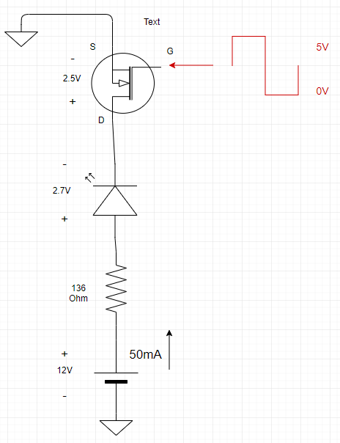Since super bright LEDs require a significant amount of current to operate at full brightness, they cannot be directly connected to the Arduino Nano. The Arduino cannot simply supply all that current to the LEDs and will be limited to 40mA at each PWM pin, and all the pins will provide a combined current of 200mA [1]. Thus, the current at each PWM pin must be limited to say 30mA to avoid damage to the Arduino module. AA alkaline batteries can be used instead to power up the LEDs and the rest of circuitry since they can provide constant 50mA and 1.5V [2].

Thus, since the Arduino is unsuitable for the task power, the LEDs it would be used only to control the LEDs, as seen in Figure 1. This circuit is based on the fact that MPU6050 gyroscope will provide the Arduino chip with rate of change of the handlebar of the bicycle and based on the Arduino code written the Arduino will change the duty cycle of the PWM signals that would be used in each pin. In this project, only 3 LEDs will be used, and thus only 3 PWM signals would be needed from the Arduino. The circuit in Figure 1 is what would be most suitable to perform the task of changing the intensity of lighting on the bike. That circuit only requires four components: a battery, an LED, a resistor, and an N channel MOSFET.

A MOSFET is used because it is voltage controlled, and it is easier to control. A BJT can as well used, but the base current must be controlled to be or, which is usually the current gain for many BJTs. With MOSFETs, as long as the control voltage Vg is higher than the threshold voltage Vgs(th), the MOSFET will be on conducting or it will be off if the PWM signal is lower than the threshold voltage. For 2N7000, which is the N-channel MOSFET used in this design, the datasheet specifies that the threshold voltage is 0.8V low enough and the transistor is excellent to use in the project [3].

Figure : LED control circuit.

The MOSFETs, resistors and LEDs are all readily available in the Electrical Wing shop. Since the 2N7000 MOSFET and the super bright 2.7V LEDs are available in the shop, the only selection left is the battery and the resistance needed to limit the current in the circuit. To select the battery size, the battery should be suitable to be applied to the Arduino Vin pin. Since the Arduino Nano can accept from 7-12V input voltage, a 12V battery is most suitable. The battery has to be big enough to power the Arduino module, and three LED control circuits as can be seen in Figure 2 and   
Figure 3. Once the battery is selected, the resistor value should be calculated based on the supply battery current which is 50mA. This value can be calculated by Ohm’s law, i.e. . The 2.5V seen across the transistor is the difference in voltage between the drain and source when the transistor is on, refer to datasheet [3].

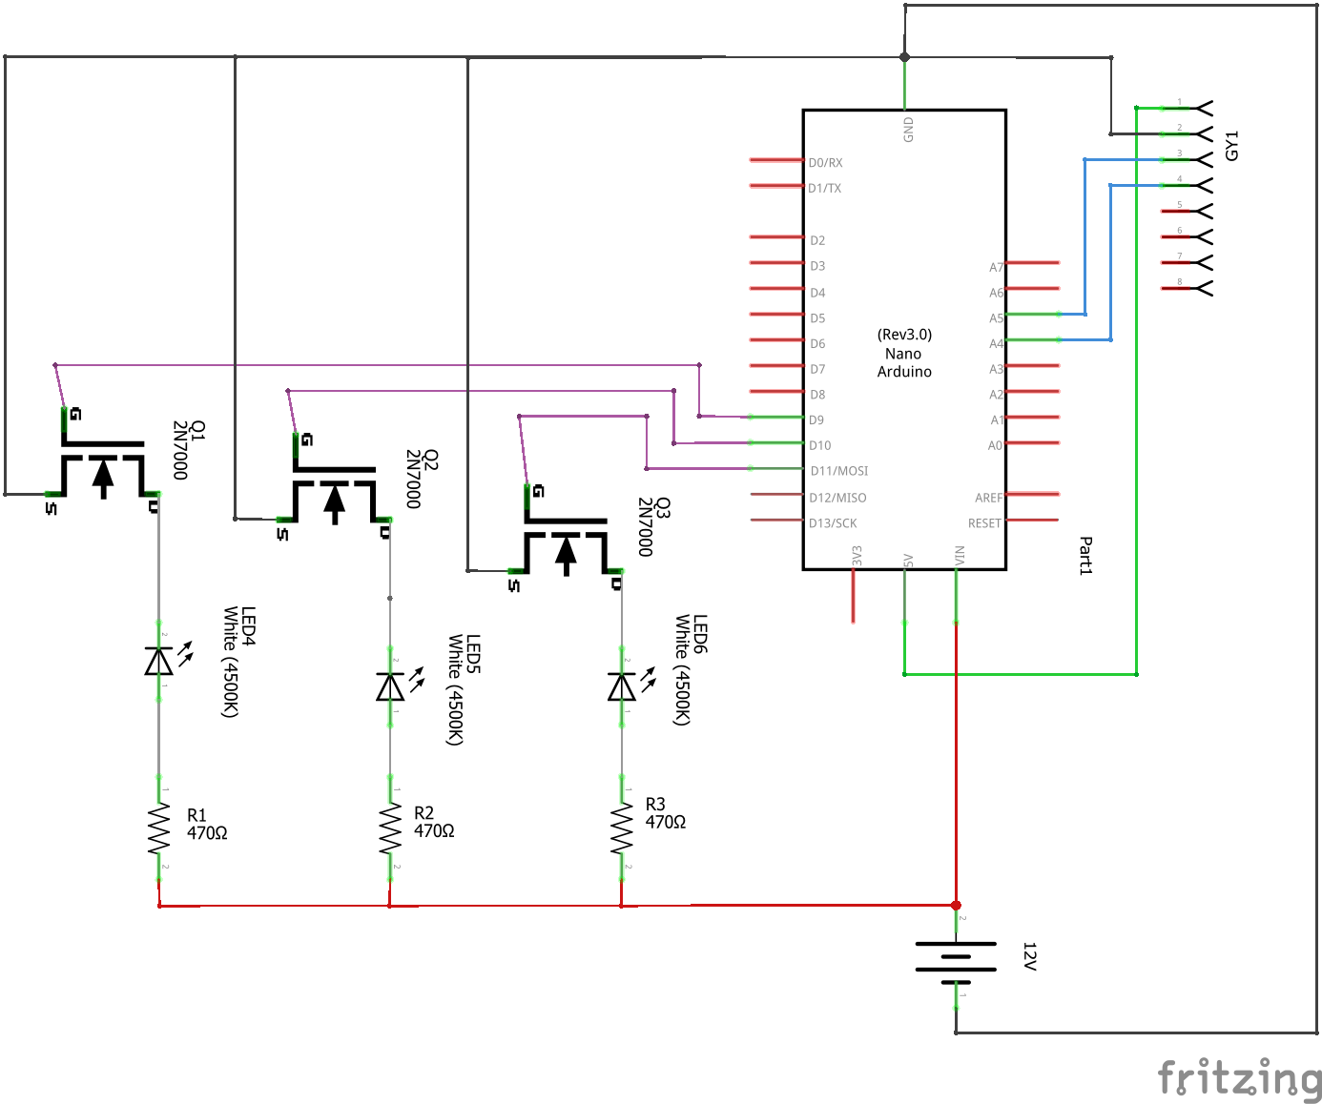

Figure : Schematic of bike light.

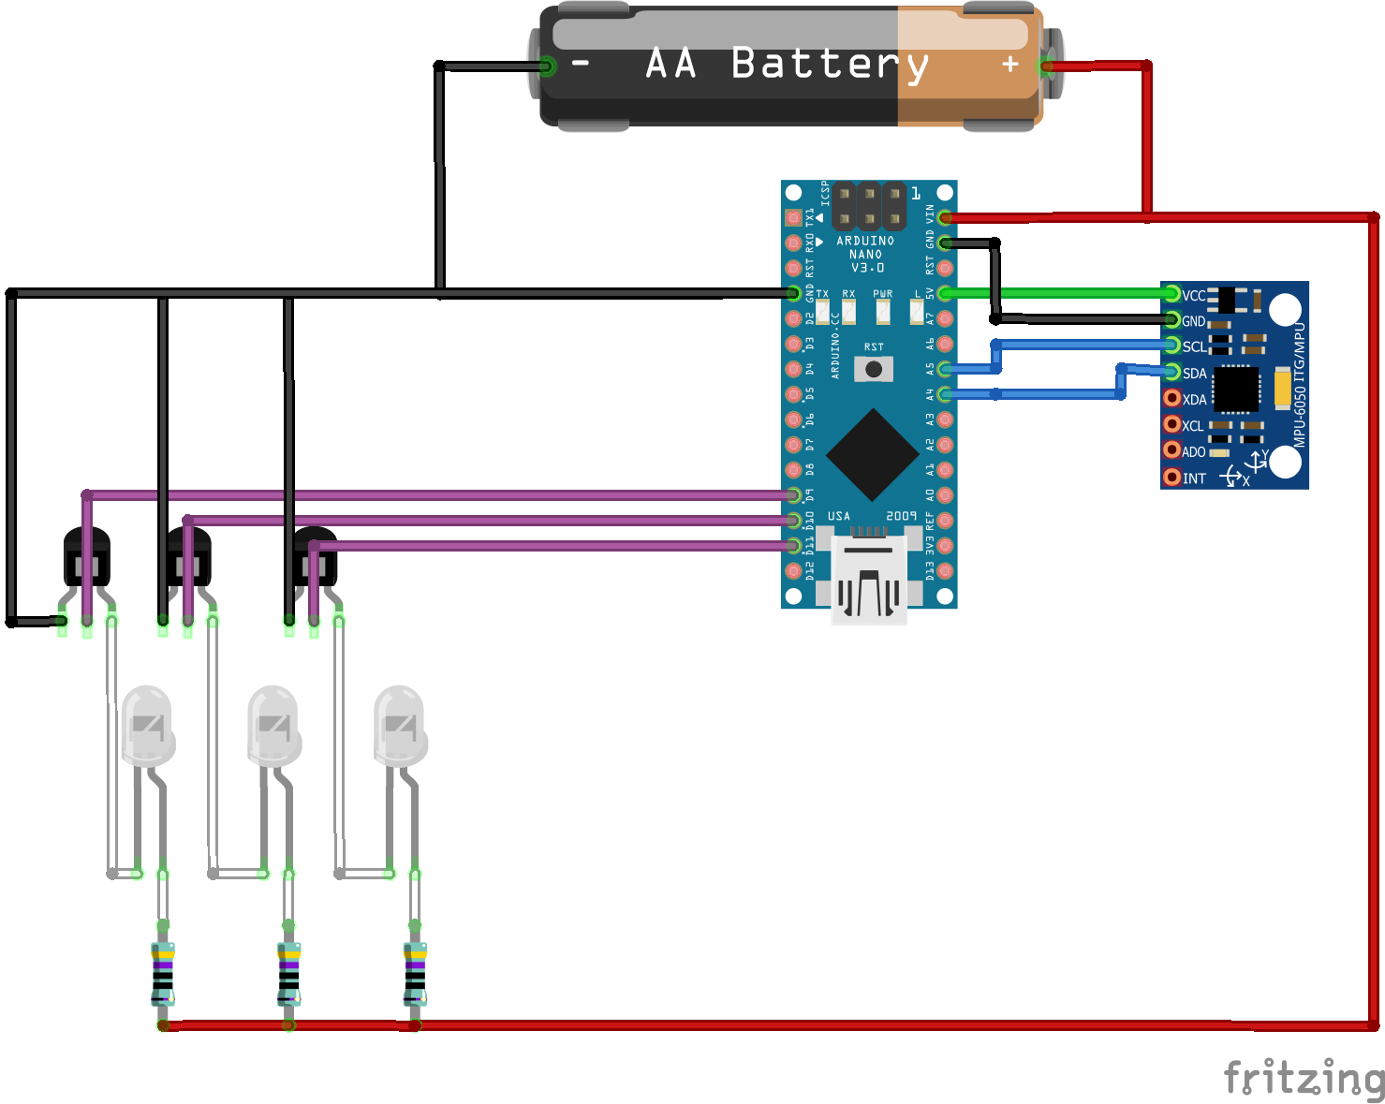

Figure : Automatic Beam Bike Light Schematic.

The issues and inaccuracies can be solved by redesigning bike lights. The handle bar would comprise of three LED’s placed on the outer surface of the case. The problem of detecting and illuminating turns can be solved by installing a motion-tracking sensor. The sensor would be installed on the handle bar detecting the angle of movement. It would signal the LED’s connected to the circuitry to highlight the area of turn. Therefore, mitigating the probability of misjudging the road.

The issue of battery efficiency can also be solved by installing the redesigned bike lights. They eliminate the need for headlights, making it more energy efficient.

The LED at the center

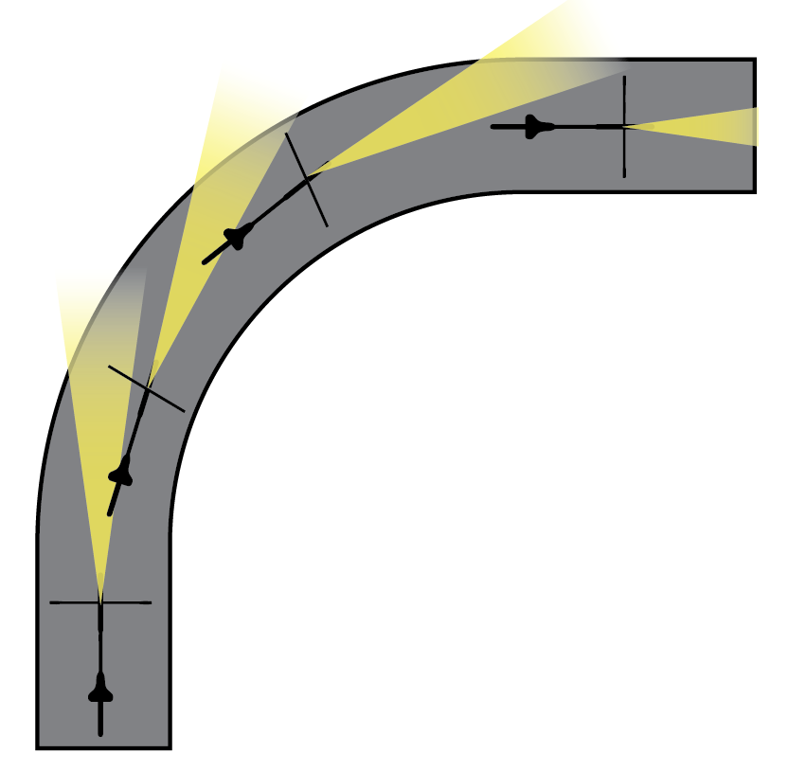

Specifications

MPU6050:

It is a Motion Tracking device. It consists of a combination of six axis – a three-axis gyroscope and a three-axis accelerometer. The device can be used for measuring rotation velocity, orientation and displacement. The Yaw, Pitch and Roll can be calculated using the MPU6050

Arduino Nano:

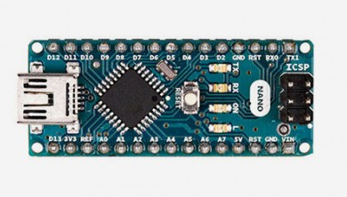

Figure 1:https://store.arduino.cc/usa/arduino-nano

Arduino Nano is a small and compatible version of Arduino Uno. The Arduino Nano is based on the ATMega328p microcontroller. The operating voltage of the Nano is 5V and the input voltage can be varied from 7V to 12V. It consists of 14 digital pins, 2 reset pins, 8 analog pins and 6 power pins. The Arduino Nano consists of a crystal oscillator and operates on a frequency of 16MHz. For the project, the team utilized pins A3, A5 and A7 for producing the PWM signals from the Arduino.

Working of the Product:

The Gyroscopic sensor is placed on the handlebar. It calculates the rotation angle of the handlebar. For this project, the Gyroscope measures the angle along the Z-Axis. The Arduino Uno acts as an interface between the Gyroscope and the LED’s. The output from the gyroscopic sensor is fed into the Arduino Nano which activates the PWM signals available on the pins A3, A5, A7. These signals are applied as an input to the base of the 2N7000 Mosfet, which acts as a switch. The input to the Mosfet activates the LED’s (Light Emitting Diodes) and controls the intensity of light. For example, if the handlebar is turned towards the right, then the intensity of the three LED’s descends from the left to the right and vice versa. The Mosfet is connected to a 100kΩ resistor. The circuitry is enclosed in a case, with the LED’s placed on the front side of the case. The 12V battery is shared between the Vin pin of the Arduino Nano and the Circuitry which includes powering the Mosfet and the LED’s. The switch is used to turn the system ON or OFF.

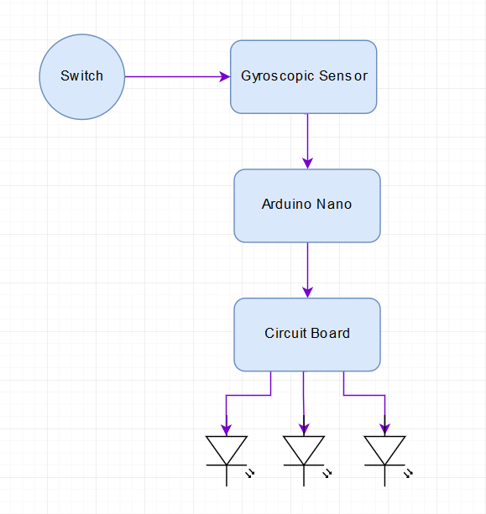

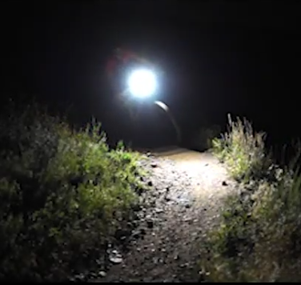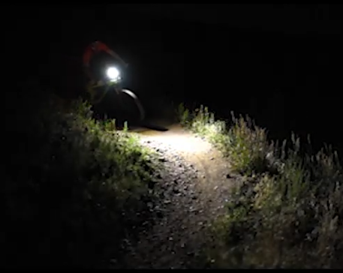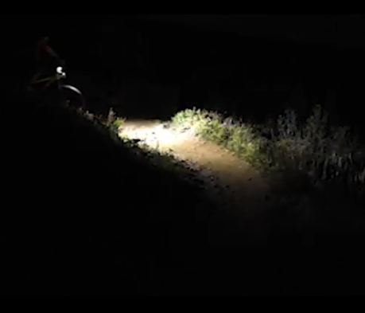

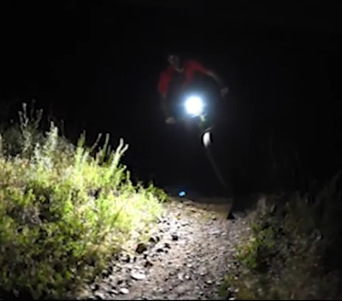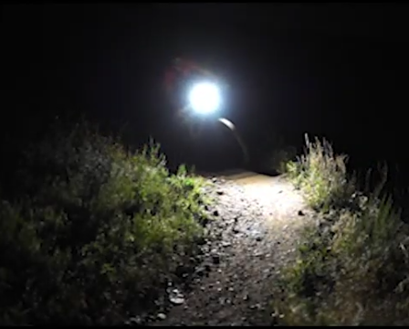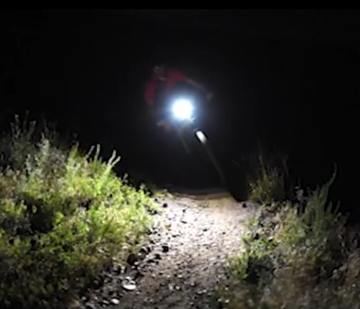

Costing:

This section describes the costing of the components used for the ‘Automatic Beam Handle Bike Lights’. The various components, their individual cost and the total cost of the project are listed below in Table XXXX.

|  |  |  |
| --- | --- | --- |
| Components | Cost for each component | Total Cost |
| Arduino Nano |  |  |
| Gyroscopic Sensor |  |  |
| Transistors |  |  |
| LED |  |  |
| Resistors |  |  |

Market Strategy:

This product aims to target

Improvements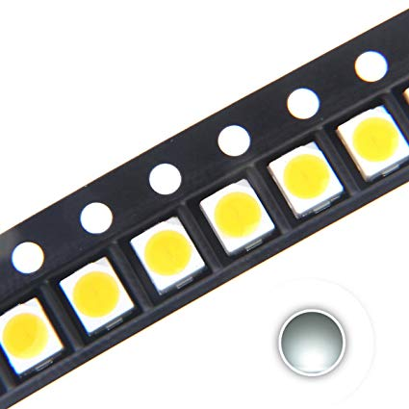

Surface Mount LED (SMD): SMD’s are compact and can perfectly be soldered onto a PCB. They are durable and provide high lumens approximately 1080 lumens per meter. They are cheap and consume less power, therefore can act as a replacement to High lumens LED’s. Considering the durability of regular LED’s used in bike lights these LED’s can serve for a longer duration providing more lumens output.

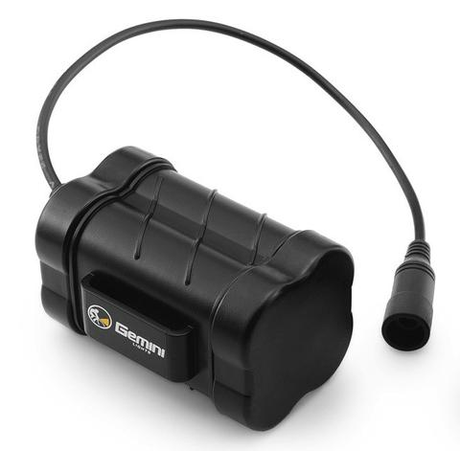External Batteries: The designed system, currently comprises of an internal battery, which has a short shelf life and would dissipate energy at a very high level. Thus the biker would have to replace his batteries regularly. External rechargeable batteries are energy efficient and are suitable for regular use. They are portable and can be recharged after use. They charge quickly and have a longer shelf life as compared to the alkaline batteries currently used in the project.

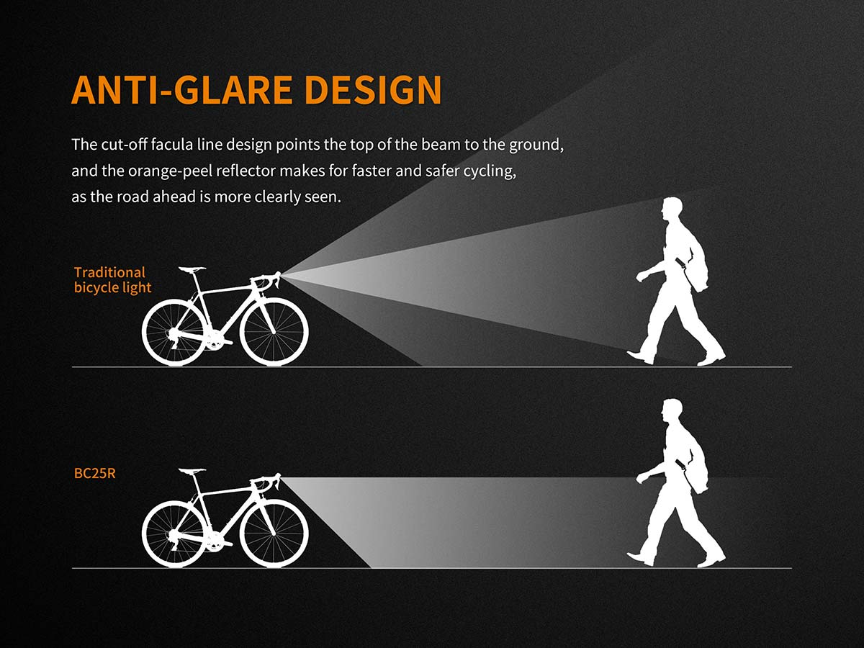Anti-Glare Design: If the bike lights comprise of LED’s of high lumens, they tend to reflect a high intensity of light. If there are incoming motor vehicles, the intensity of the bike lights can blind the motor vehicles. Therefore, to eliminate this issue, bike lights can be designed in a half-cut conical shape to point the beam towards the ground as shown in Fig XXXXX. It provides safety to the cycle commuter and clearly illuminates the road. Therefore, anti-glare design would not cause visibility issues to incoming motorists.

LDR to turn the system ON/OFF:

LDR (Light Dependent Resistor) varies its resistance depending upon the intensity of the light. For future improvements we would use the LDR to regulate the overall intensity of the LED’s. If the biker is travelling through a poorly lit street, the intensity of the lights would be more and if he’s travelling through a well-lit area then the intensity of the LED’s would be low.

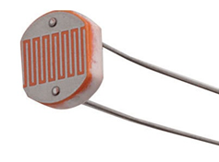

# References

|  |  |
| --- | --- |
| [1] | Farnell, "Arduino Nano," http://www.farnell.com/datasheets/1682238.pdf, n.d., p. Arduino Nano datasheet. |
| [2] | A. Kumar, Can we achieve 1A current from 1.5v battery cell, if yes for how long?, https://www.quora.com/Can-we-achieve-1A-current-from-1-5v-battery-cell-if-yes-for-how-long#targetText=Normal%20AA%2FAAA%20batteries%20that,(Source%3A%20Wikipedia)., Mar 7, 2016. |
| [3] | ONSemi, "Small Signal MOSFET 200 mAmps, 60 Volts," https://www.onsemi.com/pub/Collateral/2N7000-D.PDF, 2011, p. 2N7000 datasheet. |
| [4] | Farnell, "Arduino Nano," http://www.farnell.com/datasheets/1682238.pdf, n.d., p. Arduino Nano datasheet. |
| [5] | A. Kumar, "Can we achiece 1A current from 1.5V battery cell, if yes for how long?," https://www.quora.com/Can-we-achieve-1A-current-from-1-5v-battery-cell-if-yes-for-how-long#targetText=Normal%20AA%2FAAA%20batteries%20that,(Source%3A%20Wikipedia)., Mar 7, 2016. |
| [6] | OnSemi, "Small Signal MOSFET 200mAmps, 60 Volts," https://www.onsemi.com/pub/Collateral/2N7000-D.PDF, 2011, p. 2N7000 datasheet. |